**HAEF IB – FURTHER MATH HL**

**TEST 1 – (P1: Without GDC)**

**Marks:____/40**

**Matrices – Vector Spaces**

*by Christos Nikolaidis*

**Name:____________________________________**

**Date: 17 – 10 – 2016**

**Questions**

1. *[maximum mark: 4]*

Let ***A***, ***B*** and ***C*** be non-singular *n*×*n* matrices, ***I*** the *n*×*n* identity matrix and *k* a scalar. State which of the following statements are **correct**. For each incorrect statement, write down the correct version of the right hand side.

(a) (***A*** + ***I***)(***A*** – ***I***) = ***A***2– ***I*** *[1 mark]*

(b) (***A*** + ***B***)(***A*** – ***B***) = ***A***2– ***B***2 *[1 mark]*

(c) ***C*** 2 – ***AC*** = ***C***(***C*** – ***A***) *[1 mark]*

(d) (***AB)T*** = ***AT***B***T*** *[1 mark]*

1. *[maximum mark: 5]*

Consider the system of simultaneous equations.

*x* + *ay* +*bz* = *c*

*ax* – *y* + *az* = *b*

*bx* + *y* + *dz* = *3b*

Given that (1,1,1) and (8,5,– 4) are solutions of the system, find



1. *[maximum mark: 7]*

Let

 and 

1. Find  by transforming into the reduced row echelon form. *[4 marks]*
2. **Hence** solve. *[3 marks]*
3. *[maximum mark: 10]*

Let  and be two vectors , where .

1.  is linearly independent **if and only** **if**  *[5 marks]*
2. ,  are linearly dependent **if and only if**  is a multiple of . *[5 marks]*
3. *[maximum mark: 14]*

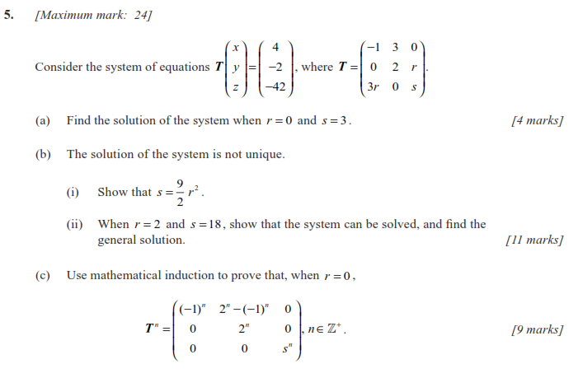

*[4 marks]*

**

*[10 marks]*

**HAEF IB – FURTHER MATH HL**

**TEST 1 – (P2: With GDC)**

**TOTAL SCORE**

**Marks: __ /80 ( %)**

**Grade: ____**

**Marks:____/40**

**Matrices – Vector Spaces**

*by Christos Nikolaidis*

**Name:____________________________________**

**Date: 17 – 10 – 2016**

**Questions**

1. *[maximum mark: 5]*

Let

 

with . Find .

*[5 marks]*

1. *[maximum mark: 4]*

Write down the **reduced row echelon form** of the augmented matrix corresponding to







**Hence** find the general solution of the system.

1. *[maximum mark: 5]*

Let

, , 

1. Show that ,, are linearly independent. *[2 marks]*
2. Express  as a linear combination of ,,. *[3 marks]*
3. *[maximum mark: 8]*

Consider the matrix



1. By observing the first powers of(that is , ,) guess a formula

for  in terms of *n*. *[3 marks]*

1. Verify that your guess holds for the inverse matrix  as well. *[2 marks]*
2. Given that  has the form you guessed, show that  also has this form. *[3 marks]*
3. *[maximum mark: 8]*

Let

 

1. Show that is a subspace of . *[3 marks]*
2. Investigate whether is a subspace of . *[3 marks]*
3. Explain why  is not a subspace of . *[2 marks]*
4. *[maximum mark: 10]*

Suppose that

 is a singular matrix (i.e. )

is an matrix

 is the  zero matrix.

1. Write down the number of solutions of  *[1 mark]*

Let  be a fixed solution of .

1. Show that

 is also a solution of  **if and only** **if**  is a solution of . *[6 marks]*

Let  and be two distinct solutions of 

1. Show that  is also a solution of  for any . *[3 marks]*